Date: Bottle number:
Team members:

- Secretary 1 (Write down the data on the board)
- Secretary 2 (Write the justifications):
Joint data collection
Write down the details of the colleagues you think fit your bottle:


Data analysis

Hypotheses about the content
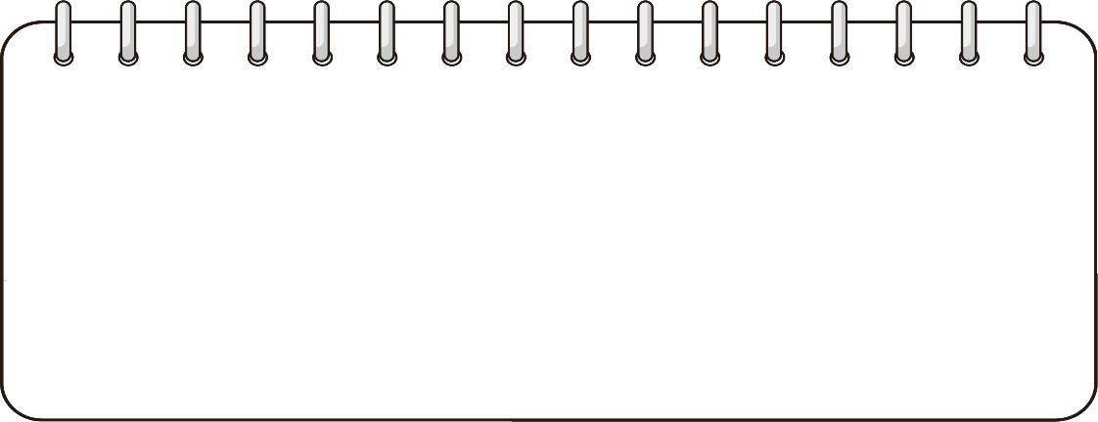
Confidence level
Mark where you would place your level of confidence in your hypotheses:
Gens segur Poc segur Bastant segur Totalment segur

